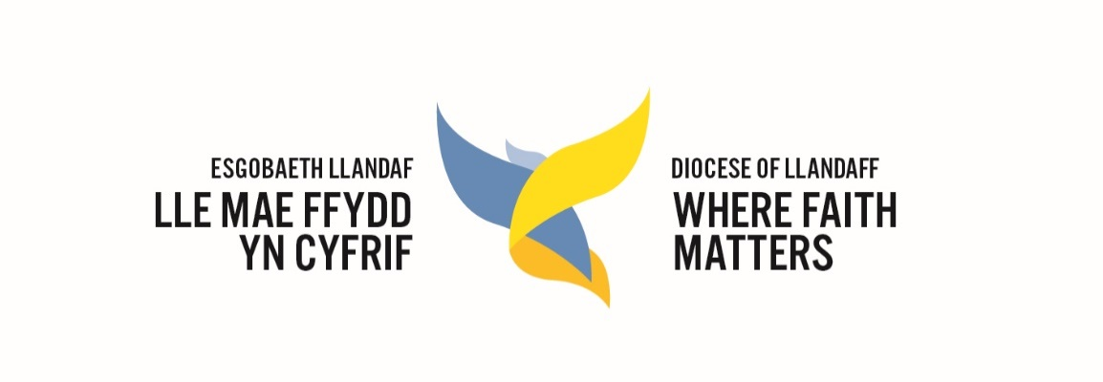

Llandaff Diocesan Conference 2021
Report of the Diocesan Standing Committee

The Standing Committee has met three times since the last Diocesan Conference, all held online via Zoom in response to government guidelines during the Covid 19 pandemic. We intend to return to meeting in person as soon as it is safe to do so.

During its regular meetings, the Standing Committee has dealt with the following items of business, among others:
- Receiving updates on the progress of the Diocesan Vision (including activities supported by the Church in Wales’ Evangelism Fund) and the recruitment of a Vision Programme Manager as well as Engagement Workers funded by the Evangelism Fund Grant.
- Discussing the feedback from the Diocesan Conference in 2020 and planning for the Conference in September 2021.
- Receiving regular reports from the Diocesan Board of Finance and the Parsonage Board.
- The impact of Covid 19, financial support, how ministry was continued, sometimes remotely or online, in the face of changing regulations, and plans for re-opening and returning to normality.
- Approval of the Diocesan Environmental Declaration, Policy, and target to reach carbon net zero by 2030.
- Adoption of the Church in Wales Safeguarding Policy.
- Establishment of Ministry Areas, and the diocesan support for it including providing financial, written and legal resources, convening Colleges of Ministry Area Lay Chairs, Treasurers and clergy.
- Relaunching the Gender Working Party as the Diocesan Gender & Inclusion Group.
- Exploring a new diocesan partnership with the Diocese of Pennsylvania in the Episcopal Church of the United States of America.
- Amending the Diocesan Constitution to meet the requirements of the changed parochial structure.

It agreed the following changes to parishes:
- To unite the parish of Gabalfa with the Conventional District of Tremorfa.
- To change boundaries of Pontypridd, Elwysilan & Caerphilly, Abercynon, and Ystrad Mynach.
- To move the parishes of Tonyrefail and Gilfach Goch into the Benefice of Llantrisant and into the Deanery of Pontypridd.
- To change the name of the Benefice of Caerphilly and Eglwysilan change its name to Caerphilly and the Aber Valley Ministry Area.
- To change the Conventional District of Urban Crofters to the Parish of Urban Crofters (St Anne’s).
- To change the Conventional District of St Teilo to the Parish of Citizen Church.
- To reverse the 2019 declaration of redundancy of St Peter and St Cenydd church in Senghennyd and move it to Citizen Church, noting the support and active collaboration of the Caerphilly and the Aber Valley Ministry Area.
- To ungroup St German’s Roath from St Saviour’s Splott.
- To approve the legal formation of the Ministry Areas.

The Ven Mike Komor
Acting Diocesan Conference Secretary

