PRACTICAL SUGGESTIONS TO HELP CHURCHES SAVE ENERGY AND MONEY

We are grateful for permission to use this guidance (adapted for Wales) which has been created by the Cathedral and Church Buildings Division of the Church of England, drawing extensively on existing work from Oxford Diocese, and with contributions from the Church Energy Advisors Network and attendees at the 2022 DAC Conference.

Watch: | Watch this useful webinar on “Housekeeping and Quick Wins”. It is full of practical advice. HOUSEKEEPING AND QUICK WINS - YouTube  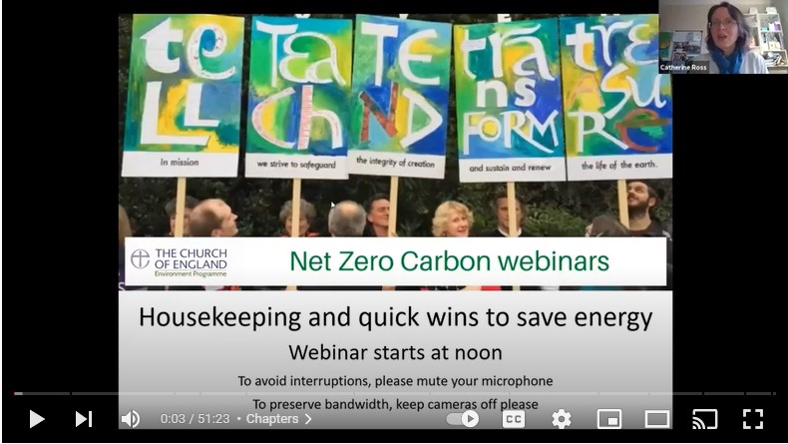
National guidance note: | For more information on energy efficiency, read the CofE energy efficiency guidance: ENERGY: (churchofengland.org)
Electricity and gas bills: | - Check on a winter energy bill that you are not paying more than 5% VAT. Most churches should be paying just 5%, and NO Climate Change Levy (CCL). The exceptions will be churches who hire their premises out commercially.  - Check any Feed in Tariff (FiT) charge on your bills is correct  - A dual rate electricity tariff can be an advantage for churches, but check your meter shows correct time and date  - Switching to renewable energy is the aim, as we work towards net-zero carbon, but at the moment switching is difficult. Unless your contract is ending soon, you may wish to stay where you are, until prices settle. As circumstances change, speak to Parish Buying, to see if the Green Energy Basket can offer you a better deal.
Know what you use: | - Regularly check your readings, and look for patterns; is something being left on which shouldn’t be on overnight, or when the church is empty?  - Smart meters can provide detailed use information to analyse. If you don’t have one, speak to your energy company  - Completing the CofE Energy Footprint Tool helps give an idea of where your church footprint falls against other similar churches Energy Footprint Tool | The Church of England
Maintenance: | - Keeping the building wind and watertight will reduce the energy needed to warm the buildings, and reduce bills.  - Gently dust/vacuum fan convector heater fins and grills on backs of fridges to increase efficiency  - Ensure your radiators can function efficiently; bleed radiators if cold at the top, have sludge flushed-out if cold at the bottom  - Get the boiler serviced (annual gas / oil boiler inspections are strongly encouraged, and may be required by your insurance provider)  - Fix leaking taps  - Keep radiators clear of furniture or other obstructions  - Clear gutters to prevent damp problems (remember damp = cold!)  - Tackle drafts: fix broken windows (even small breakages), consider fridge magnets over large keyholes, consider curtains across doors. But don’t block air bricks or other intentional ventilation and remember some windows may need to be open during a service to let condensation out.  - Mend leaks to prevent damp problems (damp = cold!)  - Insulate heating pipes and water tanks  NB some actions in these last 3 points may require permissions, so check with your Church Buildings Officer first.
Heating controls: | - Check your thermostat settings suit your needs; try turning them down a degree or 2 and see the response.  - If there are different heating circuits for different parts of the building, make sure they are not heating empty rooms, otherwise consider thermostatic valves on radiators.  - Check that the heating timings suit your current service times. Amend them when the clocks change. Many churches find they can turn the heating off 30-45 minutes before the service ends and still maintain comfort, because of the residual heat in the radiators.  - Check the frost setting on your boiler or thermostat, if you have one, and set it correctly. Read the guidance here Microsoft Word - Managing your frost protection v5 (churchofengland.org)  - If a dual burner, the high-flame setting should be set lower than the low-flame setting (see webinar above, at 16minutes)  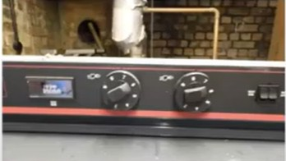  - Add timers to heaters so they can’t be left on by mistake  - If you have Drugasar, Temcana or similar heaters, check whether they have pilot lights. If they do then turn them off at the end of the heating season and on before the start of the next. The turn on should be carried out by a competent person, such as a Gas Safe Engineer to ensure the correct components are operating, including internal controls and external controls where applicable. This can save a lot.  - If radiators are next to walls, then consider putting insulating foil between the radiators and the walls  - If you are providing background heating when the church is empty, and unless the fabric, fixtures and/or fittings require it, turn it down or off. Monitor for ill effects such as mold.  - If needed, and in smaller spaces such as meeting rooms or offices, try a dehumidifier to control damp rather than heating.
Alternative heating: | - Consider how to make people warm without heating the whole building.  - You may wish to purchase a set of heated cushions, heated blankets, and/or heated floor mats, to enable you to reduce the hours you run the main space heating for. (See case study: Marown Church tries a new approach: heated cushions | The Church of England) Or use a few portable electric heaters, preferably of the infra-red variety that warm people quickly.
Comfort: | - Add cushions to seats or breathable carpet matting on the floor. This can be done without faculty under certain conditions but check with your Church Buildings Officer first.  - Encourage people to sit away from walls, doors, and other draughts  - Encourage people to sit closer together, so that their natural warmth is shared.  - Can the welcome team keep the door closed more of the time? (This often works if the welcome team stand OUTSIDE the door and then open and close it for people. Offer them a hot water bottle or heated cushion.)  - Consider using a portable screen to reduce drafts from the door
Church users: | - Check how light the building is before turning lights on.  - If you are regularly open for visitors consider motion-operated lights if not already in use.  - Turn off lights, computers/ monitors, printers, copiers etc when not in use  - Put signs next to lights, asking people to switch them off when leaving  - Create clear instructions for groups hiring the church  - If possible, plan your scheduling so that activities are back-to-back on fewer days, so that heating up from scratch happens less often  - Can service times be adjusted in winter, happening later in the morning or early afternoon, when the solar gain through the windows has had effect?  - Ensure thermostats are tamper proof or located where the general public cannot access  - Close doors when rooms not in use, and turn off radiators when rooms are vacant longer term (note - see previous comments on damp)  - Don’t overfill urns and kettles  - Appoint volunteer champions to remind people (gently) to save energy
Lighting: | - Do all parts of the church need to be lit, for the current number of hours?  - Consider reducing the hours/days your floodlighting runs for. Consult your community, who may be happy when they understand the need. Some churches turn floodlights off entirely except for special events / holidays.  - Use dimmers if you have them. If lighting is LED, ensure that the correct type of dimmer is being used.  - Switch bulbs to LED alternatives where possible, using a reputable brand (LEDs use up to 90% less energy). Start with simple bulb to LED lamp switches. More complicated lighting may require outside help.  - See the CofE webinar here: Effective management of lighting towards net zero, from the CofE Environment Programme - YouTube
Appliances: | - Many dishwashers have an ‘eco’ setting, using less electricity and water  - Make a plan to budget for energy efficient appliances when your current appliances fail  - Energy labels have changed on most items; look for a rating of C or higher  - Energy labels for ovens, tumble dryers, air conditioners, space and water heaters have not yet been updated so you’re still looking for A+ and above  - Check that fridges and freezers do not need defrosting and turn them off if there is nothing in them.
Water use: | - Water companies often provide free water saving gadgets which reduce waste and therefore bills. Speak to yours and see what they offer.  - Where possible, check water temperatures are not higher than they need to be. turn down the water temperature somewhat.
If needed, consider alternative venues: | - You may want to consider moving worship, meetings, and/or other activities into a smaller part of the church which is easier to heat, and where local heating is more effective, such as the chancel or the lady chapel. Some activities, such as PCC meetings and toddler groups, might be able to move to an alternative venue such as a school hall.  - Live-streaming services held in the church may be a way to allow more vulnerable people to participate throughout the winter.  - Some parishes may reach the point where they need to consider moving worship out of the church entirely during the coldest days of winter. There are significant missional implications to this so discuss with your Archdeacon first.
Plan ahead: | - Create a plan for your church using the free self-guided Practical Path to Net Zero Carbon for Churches: A practical path to net zero carbon.pdf  - Want an external view? Ask us about a subsidized energy-audit
Further Information:
- Case Studies: Net Zero Carbon and Environmental case studies | The Church of England
- Guidance: https://www.churchinwales.org.uk/en/about-us/our-campaigns/environment/
- Net Zero Webinars : Webinars on getting to net zero carbon | The Church of England
- Fundraising: Fundraising for Net Zero Carbon and the Environment | The Church of England
- A Rocha UK Eco Church resources: Resources - Eco Church (arocha.org.uk)

