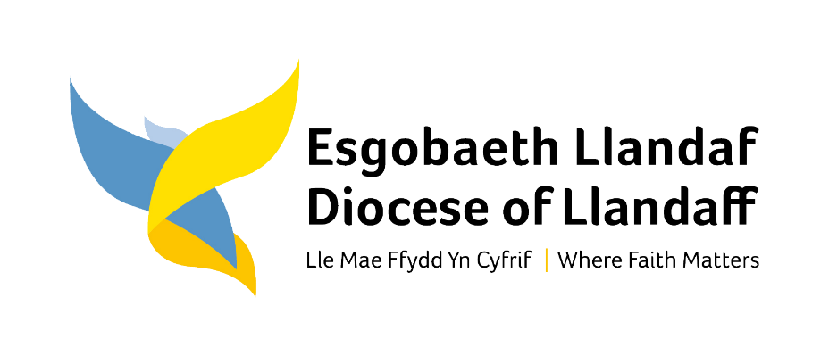
Audience | Llandaff Diocesan Conference
Purpose | - Report on the work of the Standing Committee in 2023
Author | H Morgan (Registrar) and J Laing (Diocesan Secretary)
Date | 22 September 2023
Action | Conference is asked to note the report

Governance and Administration
Following last year’s elections for a new triennium to Diocesan Conference, this was a new Standing Committee (DSC). In the first meeting of the year, the Registrar outlined the role of the DSC in articulating vision, identifying priorities and setting strategy, and its relationship with the Diocesan Board of Finance (DBF) and other key Diocesan Committees. Two new Vice Presidents, Revd Zoë King and Ms Brianna Rouse, were welcomed into their new role.

DSC noted that elections would be run electronically over the summer, overseen by the Archdeacon of Margam, and that at the end of the year the initial term of Lay Chairs would come to an end. The Bishop requested suggested nominations for lay chairs to her office, for her to make appointments for the next triennium.

DSC heard regular reports from the Bishop and the Chair of the DBF, about the newly elected DBF, the Annual Report and Accounts of the DBF, the Electoral College, and the discussions throughout the year about the annual provision of Partnership and Structural Resilience Funding from the Representative Body, and the Provincial Growth Fund.

The DBF Chair reported on the committee structure and co-option of members to ensure the right balance of membership, skills and experience for good governance. Following much work during the year, the last area to be addressed was property. It has been agreed, with advice from the Diocesan Registrar, the approval of the Representative Body and the blessing of Bishop Mary to combine the meetings of the Parsonage Board and the Churches and Pastoral Committee into one meeting where both will work together as the “Diocesan Property Group”.

This Diocesan Property Group will undertake the work of both the Parsonage Board and the Churches and Pastoral Committee and be populated in line with the Church in Wales’ constitutional requirements for each group. It will also oversee any activities relating to properties that are legally owned by the Llandaff Diocesan Board of Finance. A new Joint Education Committee will work with Monmouth Diocese in relation to activities regarding schools and mission in educational settings.

The new Diocesan Property Group will be chaired by Catherine Nightingale, Chair of the Parsonage Board supported by James Laing as Diocesan Property Group Secretary. The Chair thanked colleagues who have put themselves forward to join the group: the results of Conference elections results to this group will be announced at Diocesan Conference on 28th September 2023. The remaining Bishop’s appointments to the group will be processed straight after Conference and then the new ways of working can begin.

The Diocesan Property Group recognises that the Diocese is fortunate to be supported by excellent property and central support colleagues who have the expertise and experience to help ensure that our clergy are appropriately housed and our churches are cared for. They will now regularly come together as a new Executive Property team to progress operational and in-budget Diocesan Property Group matters. This will help the Diocesan Property Group to bring a more strategic focus to its activities whilst being assured that the very necessary day-to-day activities are in safe hands.

The Diocesan Secretary reported on the Diocesan staff team, including new recruits to support the Vision delivery and focus on growth, and the new hybrid working out of six deanery hub offices, which will be reviewed at the end of 2023.

Transparency and Communication
The DBF Chair reported back from meetings of the Representative Body about the Provincial funding and financial structures, and GB representatives reported back from the April meeting of the Governing Body with a focus on care for the environment and the importance of every church in every MA to consult the Energy Footprint tool which is on the Church in Wales website at https://www.churchinwales.org.uk/en/about-us/our-campaigns/environment/

DSC adopted the Church in Wales Dignity Charter (https://www.churchinwales.org.uk/en/clergy-and-members/dignity-charter/) and commended it to all MAs to adopt for themselves, alongside work towards an ever more inclusive and accessible Church, a theme which will be explored further in the Advent 2023 issue of Croeso.

The DSC discussed how to improve communications to the wider diocese about the Governing Body of the Church in Wales, Diocesan Conference, and DSC. This matter is improving but is ongoing, with individuals such as the Diocesan Secretary writing a blog following important diocesan meetings, and GB representatives recently committing to do the same after GB.

Archdeacons’ Matters and Territorial Reorganisation
Discussions were held about some progressive ideas and exciting projects being developed in various Ministry Areas, but no reorganisations or changes to MA boundaries were enacted.

Strategy and Vision
The Bishop underlined her support for the Diocesan Vision that Faith Matters, expressed in telling the joyful story, growing the Kingdom of God, and building our capacity to do good, and outlined the three main priorities, which are reflected in the three sessions of the Diocesan Conference on 30th September:
- Spirituality and Prayer, which started with the Festival of Prayer in July.
- Welsh Anglican Identity, a shared tradition as part of the worldwide Anglican Communion, but expressed in a local, contextual, Welsh way.
- Vocation and Leadership, recognising each other’s callings, living out our faith in vaiours ways within the one family, and calling others to join us.

Further discussions were held about delivery of the Vision, with a focus on growth which comes from God and so spiritual wellbeing is key. This includes a culture of welcome and invitation, church plants and how they are managed and nurtured within the diocese, other resource churches with particular charisms, minster churches supporting the community around them, chaplains to educational institutions to reflect a generational pivot, evangelists, leaders, and contextual Ministry Area projects or initiatives.

New initiatives and structures will require new ways of thinking about financial resources, and the DSC heard from the Diocesan Secretary about a proposed change to the process for Fairer Share, based on a conversation rather than a calculation, sensitive to local contexts, needs and abilities, while striving to fulfil the ambitious diocesan vision and give generously to a generous and loving God. This will be further explored in the Diocesan Conference and Archdeacons Visitations in the autumn of 2023.

Conclusion
Diocesan Conference is asked to note the report of its Standing Committee.

