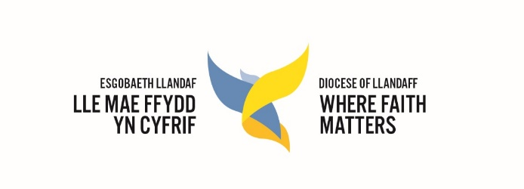
Diocese of Llandaff
Education Department
Foundation Governor Renewal/Application

Name of school

Name (Mr/Mrs/Miss/Ms/Rev’d/Dr)
Address
Post code
Telephone number
Email address

Please describe your Christian commitment and involvement

Please identify any experience/expertise you can bring to the governing body (e.g. as a former governor, teacher, administrator, in business, finance, human resources etc.)
Please complete the Skills Audit and return with your completed application

Other relevant information

Declaration of interests
Are you employed by the school? | Yes/No
Are you a parent governor? | Yes/No
Will you have a child in school during the current academic year? | Yes/No
Are you a company director, partner or owner of any business or a trustee of a charity? | Yes/No
If yes, please provide further details:

Is your spouse, or anyone living with you, employed by the school? | Yes/No
Is there any other interest you wish to declare? | Yes/No
If yes, please state:

Supporting reference from parish priest
Signed
Date
For which appointment are you applying?
DEE appointment
PCC appointment

Agreement
- I confirm that I willing to serve as a foundation governor for a term of office as specified in the school’s Instrument of Government (usually four years).
- I agree to support and maintain the ethos of the school, by ensuring that the school is distinctively Christian, and that Christian values, principles and beliefs are central to its curriculum, relationships and work.
- I confirm that under the statutory guidance, I am eligible for appointment as a foundation governor and have signed the Declaration of Eligibility.
- I have read and signed the Expectations and Code of Conduct from the Diocese of Llandaff.
- If I am appointed to the governing body, I will notify the Diocesan Education Executive and the clerk to the governors immediately should I resign my position or become disqualified during my term of office.

Signed
Date

I.D checked by (e.g. clerk to governors, chair of governors)
Signed
Date

In the case of PCC nominations: this has been approved by the PCC
Signed (PCC chair)
Date

We require a record of approval by the governing body of this appointment. The clerk to the governors should attach the section of the minutes from your full governing body meeting agreeing this.
Name of clerk to governors
Email address

Once completed, please return your entire application form along with your Skills Audit, by email to: deborahgriffiths@churchinwales.org.uk
Or by post to: Deborah Griffiths, The Diocesan office, The Court, Coychurch, Bridgend CF35 5EH

Personal information
The information that you provide on this form will be held on a computerised database maintained by Llandaff Diocese Education Team. Your data will be used in accordance with current data protection legislation. It is needed to process your appointment as a foundation governor and to enable us to communicate with you subsequently on matters relevant to the role.

I agree to the data provided being held and processed as outlined above.

Signed
Date

Declaration of eligibility to serve as a foundation governor
I declare that I am not disqualified from serving as a school governor and that:
- I am aged 18 or over at the date of this appointment
- I do not already hold a governorship at the same school
- I am not a governor of more than two schools
- I am not liable to be detained under the Mental Health Act 1983
- I accept that if I fail to attend the governing body meetings for a continuous period of six months beginning with the date of the first meeting I fail to attend, without the consent of the governing body, I will be disqualified.
- I am not disqualified from working with children
- I have not been removed from the office of a charity trustee, or trustee for a charity, by an order made by the Charity Commissioners or the High Court, on the grounds of any misconduct or mismanagement.
- I have not been refused an application being made to the Disclosure and Barring Service for a criminal records offence.

Signed
Date

Signature of Chair of Education Executive
Date

