Llandaff Education Team
Bereavement in School 2020

Sources: Birmingham Children Hospice, Child Bereavement UK, Kubler Ross Grief Cycle

It is important to note that each school has its own context, so policies and procedures around grief support should be adapted to suit the community in which the school is based.
Points to consider
Loss of an important milestone or experience can also impact on children’s emotional wellbeing. Policies and approaches, therefore, can support all children - not just the bereaved.
It is important to remember that not all bereaved children will require specialist support. Support of a familiar and trusted adult is key, which is why for so many children our schools are viewed as a safe place.
It is important to try and support everyone involved, usually the immediate family, if possible. As a church school, an agreement around this with your local church community would be beneficial.
The offer of spiritual support for the family should be considered. Exchanging of information and details, with agreement of the family and following school safeguarding and GDRP policy, may enable further support from the church/faith community.
Spiritual support for staff should also be considered, with the option of a service for staff or a Eucharist. Ongoing support should also be discussed.
An understanding of other faith beliefs and practices related to death and funerals is advisable.
The school may wish to have a bereavement policy. This ensures that there is a bereavement-aware culture in the school and all staff have a shared approach to supporting children and families. It also supports staff in times of crisis when clear thinking may be difficult owing to the effects of shock. As a diocese, we would recommend that this policy is developed alongside clergy and shared with the church community.
People can find discussion around death difficult and this can sometimes lead to people avoiding the subject so as not to upset the child. The advice is to acknowledge the death and take time to listen. This acknowledgement may trigger a difficult conversation or upset the child but this can allow an outlet for grief and is an important part of the process.
It is also advised to have a whole school understanding around the language used when talking to children about death. Using factual language is very important, so phrases such as “I’m sorry to hear that…. has died” should be used. Euphemistic phrases such as “passed away” and “gone to a better place” have been shown to confuse children and can lead to difficulties in processing the death in the longer term.
Some adults working with children express concern about not knowing what to say but the advice is that being honest about not knowing the answer will be more supportive rather than avoiding a conversation.
Puddle Jumping
Grief for young children can be described as puddle jumping. Many young children (particularly below the age of 5) don’t understand the permanence of death. They may dip in and out of grief like jumping in and out of puddles. This can then present in a variety of behaviours and emotions with no set pattern.

Older Children

Older children may follow a more noticeable pattern of emotions such as this example in the Kubler – Ross Grief cycle.
Children navigate through stages of denial, anger, depression, bargaining and acceptance. Each step may possibly need a slightly different approach with regards to support. Each stage will, however, benefit from an approach of acknowledgement, time and patience.
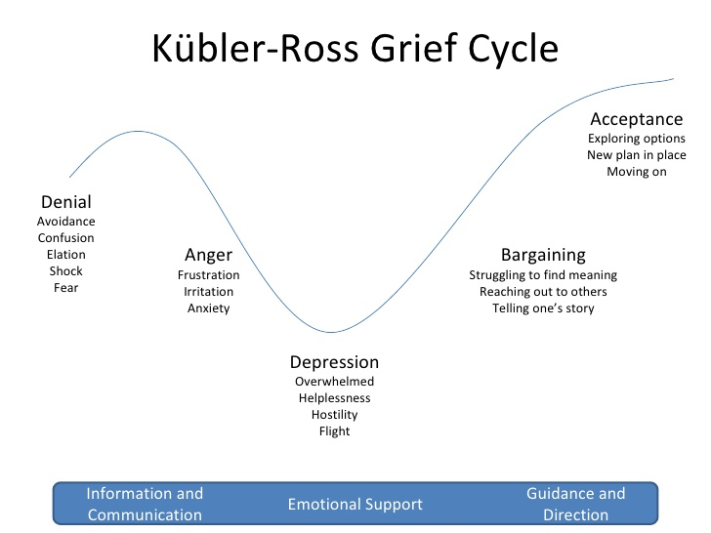

The attached example of a policy developed by Child Bereavement UK gives a detailed framework to support the writing of bereavement policies. The Child Bereavement UK website contains information and videos which can be used for staff training and support.

Some additional things to think about are:
Records and Check ins
Identifying someone to keep a record of anniversary dates ensures consistency. Marking the anniversary in some way is also recommended. Some schools send a card to the family on the first anniversary of the death, for example. Ensuring that there is a “check in” system for important dates such as the anniversary of a death or Mothering Sunday is also recommended.

Communication
You may wish to organise a back to school meeting with parent/s and the child where the child’s wishes are discussed in relation to returning to school. This allows the child to feel involved and have some control of the process. It can also allow time for any anxieties to be discussed. Children may, for example, want to discuss the death with their class or they may want their teacher to speak to their peers before they return.

Staff Support
It is important that any person allocated to support children or members of the school community can access appropriate training on request. It is also important that staff wellbeing is monitored and that signposting to appropriate support such as local authority counselling is clear. An opportunity to talk to a clergy member, or another appropriate member for the church community should also be offered if appropriate.

Office Staff
Training and clear lines of communication are essential for office staff as they are often the first point of contact for parents. Policies regarding communications should be readily available as again they are often the first point of contact for press or individuals requiring information.

Ongoing Support
Long term support for the child and the family should be considered. This is again something that the church or other faith group may be able to support with. Should the child need further support, schools should contact their local authority, Child Bereavement UK or charities such as Barnardo’s Bereavement Service for advice.

Clear Roles
A shared understanding of who does what and when will support everyone. For example, being clear about who will be the point of contact for the family is recommended, whilst recognising that the best person to liaise with the family may depend on the specific situation. Being clear about how the news is communicated to the wider community also needs agreement. The appropriate use of social media should be mentioned as part of this.

Death of a staff member
You may like to include a section on this is your policy. Again, communication and roles should be made clear. A list of next of kin should be kept securely by the school both for emergency contact and to ensure appropriate communication and support for the member of staff’s family. Bereavement in our schools is sadly something that many of us have experienced or may experience at some point. The diocese, clergy and the education team are here to support schools in any way we can. Please contact us if you have any further queries or require support.

