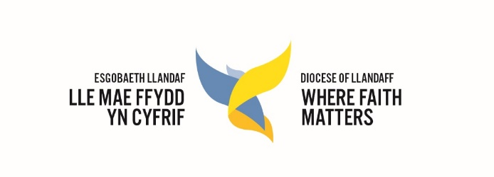
Llandaff Education
Foundation Governor Appointment Process
This guidance is for chairs of governors, clerks to governors, headteachers and incumbents of Church in Wales schools in the Diocese of Llandaff. It outlines the necessary steps a governing body should follow when filling a foundation governor vacancy where the appointing body is the Diocesan Education Executive (DEE)or the Parochial Church Council (PCC).
Diocesan Education Executive appointments:
- When you have a forthcoming vacancy, the Education Team, on behalf of the DEE, will contact the school 3-6 months prior to when a term of office expires.
- The Education Team will liaise with the school regarding the appointment of a new foundation governor taking into account the school’s needs.
- The school should contact the DEE as soon as possible if a governor stands down mid-term.
- The DEE has the right to appoint its own candidate and may inform the school of its appointment for the vacant position.
- Alternatively, the DEE may liaise with the school to accept a submission from a local nomination.
- The candidate completes the application form including appropriate references and submits it to the Education Team at the Diocesan Office.
- The candidate will have an informal interview by the Director of Education following a skills audit looking at the strengths and skills needed by the governing body and what contribution the candidate might bring.
- The application is considered by the DEE who confirm the appointment.
- The Education Team will write to the clerk to the governing body and the new foundation governor confirming the appointment. Appointments are not complete until letters of approval have been sent out and are conditional on a successful DBS check. They are carried out by an appropriate designated person at the school.
Parochial Church Council appointments:
- When there is a vacancy, keep the Education Team informed in the same way as for DEE appointments.
- Local identification of possible candidates should include consideration of the skills and needs of the governing body and the skills a candidate might bring to the role.
- The relevant member of clergy then submits the signed nomination to the PCC for confirmation.
- It is essential that as part of their appointment, candidates make a signed declaration of their eligibility, like that of DEE appointments.
- The PCC minutes should record approval and the exact term of office as date/month/year (normally four years).
- The completed application form is sent by the secretary to the PCC to the Education Team for final approval by the DEE. Appointments are not confirmed until a letter of approval has been sent to the PCC secretary, the new foundation governor and the clerk to the governing body.
- Appointments are conditional on a successful DBS check carried out by a designated person at the school.
Reappointments:
In all the above situations, the process for reappointing a foundation governor whose term of office has expired is the same as for appointing new candidates. It is essential that a new foundation governor application form is completed in all instances and that the Education team is informed of all reappointments.
DBS checks:
All maintained schools have a statutory duty to ensure ALL governors have a DBS check. This must be applied for with 21 days of appointment.
Archdeacon’s substitute:
There should be provision within a school’s instrument of government for an archdeacon to appoint an ex officio substitute to the governing body where the relevant member of clergy is unavailable; for instance, during a vacancy at the parish. The education Team can advise on the process.
Eligibility:
Most foundation governors are from local Anglican parish communities. However, being an Anglican churchgoer is not an absolute requirement and there may be schools where, because of its context, it would be appropriate to appoint a candidate from outside the church community. Ideally, a candidate will have a demonstrable faith commitment and most have a sympathy for the mission and ethos of Church in Wales schools. Please refer to current guidance on criteria for foundation governor eligibility.
Application forms:
Application forms can be downloaded from the Diocesan website under the education tab. Please ensure that you make clear whether the application is for a DEE or PCC candidate.

A simple flow chart of the main stages of the appointment process is below:
All appointments:
The Education Team at the Diocese will contact the school 3-6 months before a term of office expires.
For PCC appointments:
A local nomination is approved by the PCC. The PCC submits the nomination to the DEE for approval. Successful nominations will be confirmed by a letter from the Education Team.

All appointments:
School/ clerk ensures DBS check is applied for within 21 days of appointment. New foundation governor commences term of office.

For Diocesan appointments:
The Diocesan Director of Education will contact the school if the Diocese wishes to exercise its right and make the appointment. Otherwise, the Director will liaise with the school to accept a local nomination following a skills audit. The school submits the nomination to the DEE for approval. Successful nominations will be confirmed by a letter from the Education Team.

