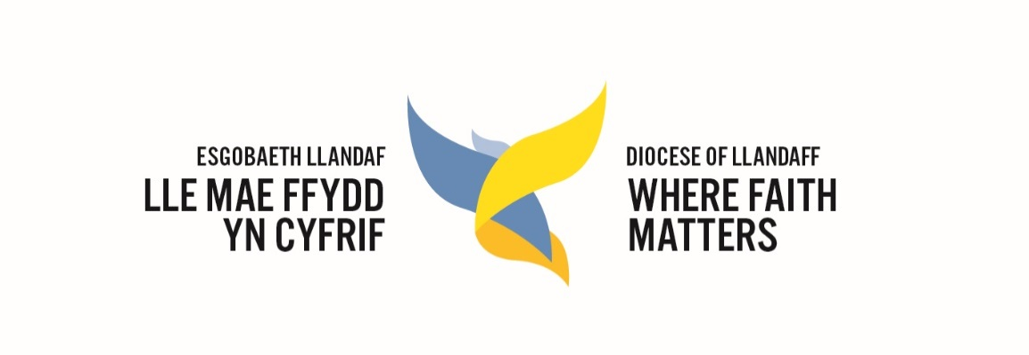

Llandaff Diocesan Conference
Minutes of the Diocesan Conference held on
15 July 2019 at Llandaff Cathedral and adjourned to 28 September 2019 at St John the Baptist CinW High School.
Present: The Bishop, 98 clerical members, 130 lay members
Apologies: 6 clerical members, 9 lay members
Diocesan staff: 17
Absent without apology: 38

Formal Business 15 July

- The evening opened with a celebration of Evensong
- Welcome. The Bishop thanked the Cathedral for hosting the meeting and welcomed new members. Between a quarter and a half of lay members were new, and there were also a significant number of new clergy attending for the first time.
- The meeting was opened at 6.30pm
- A motion was raised to suspend Standing Orders, to permit the celebration of worship at Conference to be non-Eucharistic if necessary. This was approved.
- Minutes of the Conference held on 29 September 2018 were approved and signed.
- Matters Arising from the Minutes: none that were not otherwise covered on the agenda
- The Annual Report from the Diocesan Standing Committee was provided in advance.
- The Annual Report from the Diocesan Board of Finance was delivered by the Chair Mike Lawley as a verbal report. The presentation included information on the 2018 budget out-turn. A down-turn in investments, additional contribution to Parsonage Board because of level of vacancy works and depreciation costs of school building assets, planned spending of designated reserves contributed to a deficit on both restricted and unrestricted funds. The DBF are aiming to balance the books for the operating budget (day-to-day activity of the diocese) over the next five years in order to release funds for Vision delivery. 2019 budget saw a 2% increase in parish share for which the DBF are very grateful to parishes. Current position of 2019: the budget still had to be set as a deficit budget but it has registered a surplus at end March (latest figures available), so doing much better than expected, mainly due to investment gains, vacant stipendiary post. Current work on the 2020 budget will present it in three strands: Operating Budget, Evangelism Fund bid budget, DBF Vision Fund budget.
- Questions for Oral Answer. One question had been raised, about what the Diocese would be putting in the 2020 budget to pay for the visit of Anglican Bishops prior to next year’s Lambeth Conference.
  - The response outlined the special gathering of the Anglican Communion every ten years at the invitation of the Archbishop of Canterbury which enables senior Anglican leaders to meet, pray together, discuss common concerns and, in prayer, to seek a common mind. The Lambeth Conference 2020 is due to run from 23 July to 2 August and its theme is “God’s Church for God’s World: walking, listening and witnessing together”. A hospitality initiative is being organised across the British Isles in the week preceding the Conference (16-22 July 2020); a chance for the Conference attendees to see first-hand the work and worship of their hosts, who may be dioceses or parishes. It is hoped that about 1,000 bishops and their spouses will take part in the initiative. The Diocese of Llandaff will be participating in this programme, building on existing links with other parts of the Anglican Communion and forging new friendships. The number of bishops and their spouses assigned to the Church in Wales is not yet known however. A provisional sum is being added into the draft budget.

Adjourned meeting 28 September 2019

- The Conference celebrated Eucharist together prepared by Matthew Gibbon.
- An additional agenda item was raised. The Diocese is due to elect new members of the Provincial and Diocesan Boards of Nomination this year, to serve from 1 January 2020. However, proposals for significant changes to the nominations system are currently with the Drafting Sub-Committee and are expected to come to the Governing Body in April 2020. In the light of this, the Diocesan Conference was asked to agree to extend the term of office of all current members of the Diocesan Board of Nomination, and of the Diocesan representatives on the Provincial Board, for twelve months. This proposal has the support of the Provincial Office.
- The Bishop’s Presidential Address welcomed new members of staff: James Laing as the new Diocesan Secretary and Beccie Morteo the new School Development Officer. The address focussed on the exciting year ahead with delivery of the vision and the launch of the Year of Pilgrimage. The Bishop encouraged us all to tell a joyful story and to be ambitious, change how others see the church, connect with the needs of parishes and converse with one another about things which those outside the church would recognise such as climate change, technology.
The full text of the Presidential Address may be requested by emailing Diocese.Llandaff@churchinwales.org.uk

- Delegates were divided into three groups for a carousel of presentations:
  - Vision and finance – The Vision Lead Sarah Rickett and the chair of the DBF Mike Lawley gave a presentation on the anticipated delivery of the Vision based on the outcomes of discussions of groups of clergy and lay members over the last 10 months. The Vision represents a significant drive for the sharing of faith and the growth of church to meet the needs of communities today. Activity includes the creation of new roles to support parishes directly in their mission and ministry and outreach to the community, a new vocations team and role, changes to the staff of the Diocese, investment in communications, further commitment to CAP as examples. Information was shared on the anticipated bid to the provincial Evangelism Fund which aims to support the growth of churches particularly through a focus on young people. The application is to include a targeted project in local authority schools and churches and the creation of a Resource Church, amongst other initiatives. The presentation outlined the likely spend for the Evangelism Bid at c£3m matched by the Diocese for Vision activity at c£3m over 5 years. The combined support for the Vision represents a significant financial contribution with ambitious aims and a rigorous programme of evaluation will be required.
  - Communications and values – presented by Director of Communications and Engagement the session focused on our shared values and ways of communicating, but that the message has not changed; it is still sharing the good news of Jesus. Digital means are a valuable way of communicating, especially to new audiences and Facebook specifically is a key way to stay in touch with Diocesan activity and build wider connections.
  - Llandaff Cathedral 900th plans – outlined by the Dean Gerwyn Capon, Canon Precentor Mark Preece and Canon Chancellor Jan van der Lely.
- Launch of the Year of Pilgrimage – Mark Prevett and Marc-Ashton Walford introduced the year of Pilgrimage activity and the plans for events and initiatives to mark the occasion. A new resource booklet for the year had been produced with guidance and ideas for parishes to engage with which was distributed to parish representatives. The Knit and Natter group from Merthyr Tydfil was especially thanked for the knitting of pilgrim bears to tour the Diocese and the Mother’s Union for those to be distributed to Church Schools and other church settings. The symbols of pilgrimage were displayed and a new pre-pilgrimage planning course outlined for use in parishes.
- A special item gave thanks and bade farewell to the outgoing Diocesan Secretary Mrs Rowena Small for her enormous dedication, skill and commitment to the life of the Diocese and wished her well in her retirement. She was presented with gifts to mark her time at Llandaff and she thanked all gathered for their much-valued friendship and fellowship during her time.
- Thanks were extended to the presentation leads and Matthew Gibbon and colleagues and to the school and its staff for their hospitality.
- The Archdeacon of Wrexham John Lomas was welcomed as a representative of the Diocese of St Asaph and was invited to address the conference with his reflections on pilgrimage.
- The Conference closed with a special sending-out liturgy to launch the Year of Pilgrimage .

