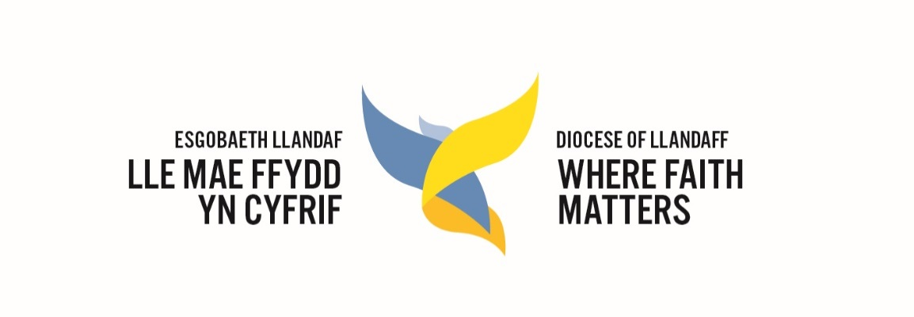

Llandaff Diocesan Conference 2020
Report of the Diocesan Standing Committee

The Standing Committee has met three times since the last Diocesan Conference, the latest (in June) held online via Zoom in response to government guidelines during the Covid 19 pandemic.

During its regular meetings, the Standing Committee has dealt with the following items of business, among others:
- Receiving updates on the progress of the Diocesan Vision and the ultimately successful bid to the Church in Wales’ Evangelism Fund.
- Discussing the feedback from the Diocesan Conference in 2019 and planning for the Conference in September 2020.
- Receiving regular reports from the Diocesan Board of Finance and the Parsonage Board.
- A proposed restructure of the diocesan staff and officers to align with the Vision Delivery Areas, to support parishes in their work to implement the Vision in their communities and incorporate new workers across the diocese to stimulate this work and share good ideas.
- The impact of Covid 19, financial support and the adoption of a Procedural Rule on Electronic Meetings.
- Approval of the use of electronic means of voting in elections for which the Diocesan Conference is responsible.
- Approval of latest Partnership Agreement between the Diocese of Uppsala in the Church of Sweden and the Diocese of Llandaff

It agreed the following changes to parishes:
- To unite the parish of Llanharry with the parish of Pontyclun and Talygarn.
- The creation of a Conventional District for the Church of St Teilo, Cathays, from 1st January 2020
- The Archdeaconry of Morgannwg is to be dissolved and the deaneries split between Margam (now to include Neath, Margam, Bridgend, Vale of Glamorgan, Rhondda and Cynon Valleys) and Llandaff (now to include Cardiff, Llandaff, Penarth & Barry, Pontypridd and Merthyr Tydfil & Caerphilly).
- The parish of Port Talbot St Theodore is to be united with the Rectorial Benefice of Aberavon
- In the creation of the new Rectorial Benefice of Llantrisant, some deanery changes - the parishes of Pontyclun, Talygarn and Llanharry move from the Deanery of Vale of Glamorgan into the Deanery of Pontypridd.
- The parish of Llanharan & Peterston super Montem move from the Deanery of Bridgend to the Deanery of Pontypridd.
- The following four parishes unite in the new Rectorial Benefice of Llantrisant, in the Deanery of Pontypridd: Llantrisant, Llantwit Fardre, Pontyclun, Talygarn and Llanharry, and Llanharan & Peterston super Montem (known as Brynna).
- A merger between the parish of Llangynwyd with Maesteg and the parish of Troedrhiwgarth, subject to formal approvals from each PCC.
- A merger between the parishes of Llancarfan and Llantrithyd with the East Vale Benefice. They will also thereby first move into the Vale of Glamorgan deanery, then merge with the East Vale Benefice.
- A merger between the parish of Penmark with Porthkerry & Rhoose.

The Standing Committee also received reports on:

- The Mothers’ Union, celebrating the work in each Deanery.

A further joint meeting of the DSC and the Diocesan Board of Finance is due to take place on 15 September in preparation for the conference and the year ahead.

The Ven Mike Komor
Acting Diocesan Conference Secretary

