Open our Eyes to your Presence

Prayers
Ash Wednesday / First Week of Lent
Written by Eleanor Williams (Llandaff Reader-in-Training)

To the phrase: Lord, we ask you to
The response is: Open our eyes to your presence
Lord, we ask you to
Open our eyes to your presence

If we want to take a deep breath at the start of Lent
Lord, we ask you to
Open our eyes to your presence

If we want to set off in a different direction
Lord, we ask you to
Open our eyes to your presence

If we want to increase our openhearted awareness of the world around us
Lord, we ask you to
Open our eyes to your presence

If we want to recall what we haven’t done
Lord, we ask you to
Open our eyes to your presence

If we want to do better next time
Lord, we ask you to
Open our eyes to your presence

If we want to stop over-complicating things
Lord, we ask you to
Open our eyes to your presence

If we want to cut down on our tendency to catastrophise
Lord, we ask you to
Open our eyes to your presence

If we want to keep being patient and kind
Lord, we ask you to
Open our eyes to your presence

If we want to remember why we’re doing this
Lord, we ask you to
Open our eyes to your presence

If we want to look beyond death to life
Lord, we ask you to
Open our eyes to your presence
Amen

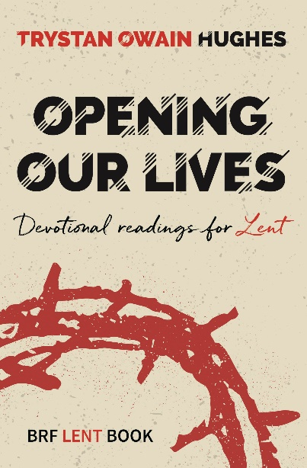
Opening Our Lives: Devotional readings for Lent – BRFonline

