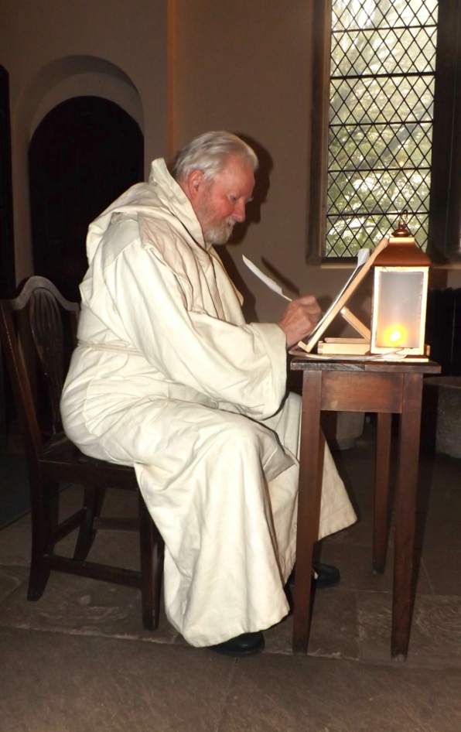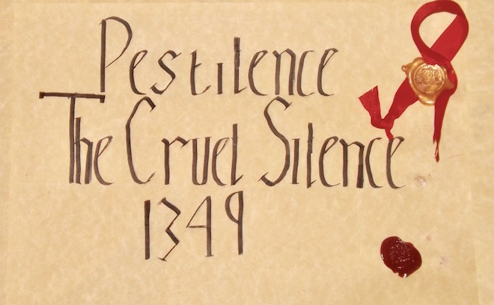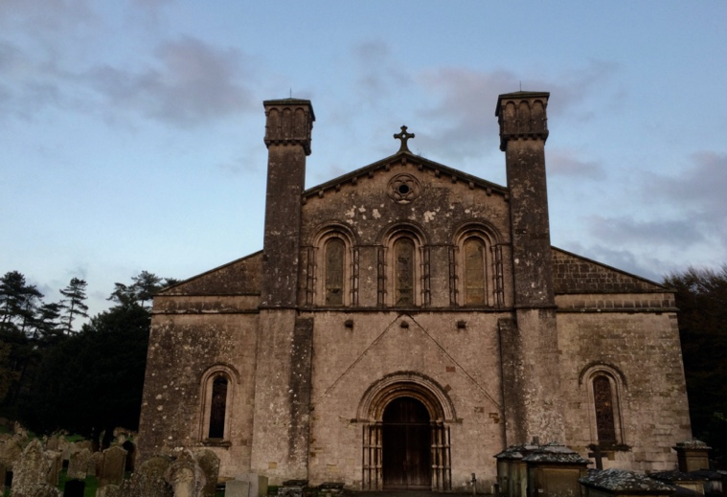

**Pestilence**

**The Cruel Silence 1349**

**Wednesday 28th April 7pm**

Join us via Zoom to experience a unique depiction of the social and economic

effects on a Monastery and Communities during

Great Pestilence in Wales 1349

Following the performance, there will be a discussion in which all can participate and ask questions of the characters.

Written, performed and produced by

Margam Abbey Theatrical History

Part of a series of performances online