Gratitude for the schools in your community by using Thankful Ribbons

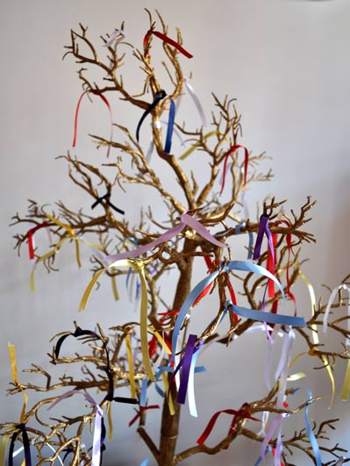

• Equipment
A branch from a tree or an artificial tree.
Lengths of ribbon or pre-made streamers
pens (ideally fabric pens).

• Set up
Option 1: prepare lots of individual pieces of ribbons or pre-made streamers to be tied on the branches of the tree.
Option 2: prepare one (or a few) long pieces of ribbon, which is attached to a large pole.

In both cases ensure that pens are easily available.

If possible, please share pictures of your local school, maybe from a website or social media or a map of your community where the school is located.
Make this a focus for the thankfulness prayers.

• Instructions
Encourage members of your church to think about the schools in your community and think about one thing they are thankful for and then write it down on the ribbon. If they want to, they can say a silent prayer as they do this.
Attach the ribbon to your branch or artificial tree or to the long length ribbon.
As they attach the ribbon ask them to spend some time in silence at the prayer station, thinking especially about the local school.

Over the week encourage people to use the Prayer Station, offering prayers of thankfulness for the schools in the Diocese.

