Seven Matters of the Heart

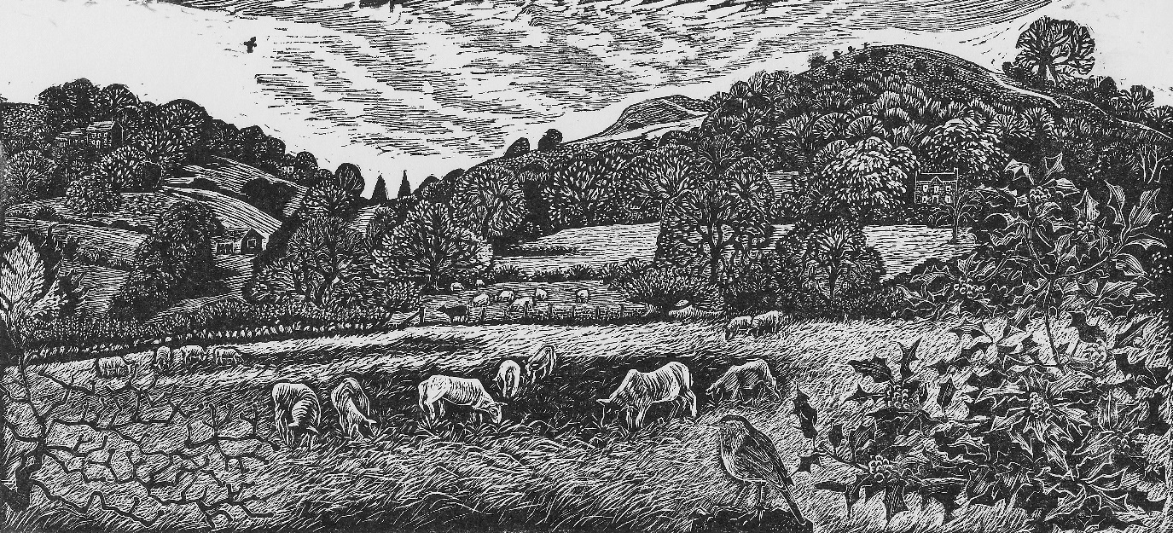

- Generosity at the heart of creation
Leader: A seed is the heart of life Gen 1:12
Reader: Then God said, ‘Let the earth put forth vegetation: plants yielding seed, and fruit trees of every kind on earth that bear fruit with the seed in it.’ And it was so.¹²……. And God saw that it was good.
Leader: When God blesses and divides something, it is not diminished Mark 6:41
Reader: Taking the five loaves and the two fish, he looked up to heaven, and blessed and broke the loaves…….and he divided the two fish among them all.⁴² And all ate and were filled
Leader: When seeds ‘die’ they produce a harvest John 12: 24
Reader: unless a grain of wheat falls into the earth and dies, it remains just a single grain; but if it dies, it bears much fruit.

ALL All things come from him
All things come through him
All things return to him Rom 11:36

- Generosity at the heart of His plan for our provision
Leader: God gave the seed as our food Gen 1: 29
Reader: God said, ‘See, I have given you every plant yielding seed that is upon the face of all the earth, and every tree with seed in its fruit; you shall have them for food.³⁰……... And it was so.
Leader: He gives seed for sowing and bread for food 2 Corinthians 9:10 Isaiah 54 :10
Reader: He who supplies seed to the sower and bread for food will supply and multiply your seed for sowing and increase the harvest of your righteousness.

ALL All things come from him
All things come through him
All things return to him

- Generosity is Gods heart
Leader: The mini gospel:
God so loved the world,
He gave His only Son John 3:16
Reader: God is love.⁹ God’s love was revealed among us in this way: God sent his only Son into the world so that we might live through him.¹⁰ In this is love, not that we loved God but that he loved us 1 John 4:8

ALL All things come from him
All things come through him
All things return to him

- Generosity at the heart of His plan for the world
Leader: We are called to bless 1 Peter 3: 9
- Do not repay evil for evil…...but, on the contrary, repay with a blessing. It is for this that you were called….
Leader: Gods plan is to bless the whole world, through his family; Gen 22:18, Gal 3:8-9.
Reader: I will indeed bless you, and I will make your offspring as numerous as the stars of heaven and as the sand that is on the seashore……¹⁸ and by your offspring shall all the nations of the earth gain blessing for themselves, because you have obeyed my voice.
Leader: ‘You give them something to eat’ Mark 6:37
Leader: Paying for the healing and care of the world, in the Fathers name Luke 10:35-37

ALL All things come from him
All things come through him

All things return to him

- Generosity at the heart of family
Leader: We are his children; we love because he loved us first
Reader: In this is love, not that we loved God but that he loved us and sent his Son to be the atoning sacrifice for our sins. ¹¹ Beloved, since God loved us so much, we also ought to love one another. ¹⁹ We love^{[b]} because he first loved us. 1 John 4:10,11, 19
Leader: We can only give in this way, if we are ‘connected’ to Him
Reader: I am the vine; you are the branches. Those who abide in me and I in them bear much fruit, because apart from me you can do nothing. John 15:5

ALL All things come from him
All things come through him
All things return to him

- Generosity at the heart of Thanksgiving (Eucharist)
Leader: His body was broken but he is He is equally, fully, present everywhere. Let us go to Him and offer our sacrifices.
Reader: A sacrifice of praise, the fruit of our lips. A sacrifice of kindness that is pleasing to God Hebrews 13: 15-16

ALL All things come from him
All things come through him
All things return to him

- We Give our heart:

Leader: Where Your treasure is, there your heart will be also Matthew 6:21

ALL All things come from him
All things come through him
All things return to him

‘Sugarloaf Fields’ by Kath Little is used with permission.
Paul says this is the gospel, ‘good news’

