Lent Prayer, Caring for Creation

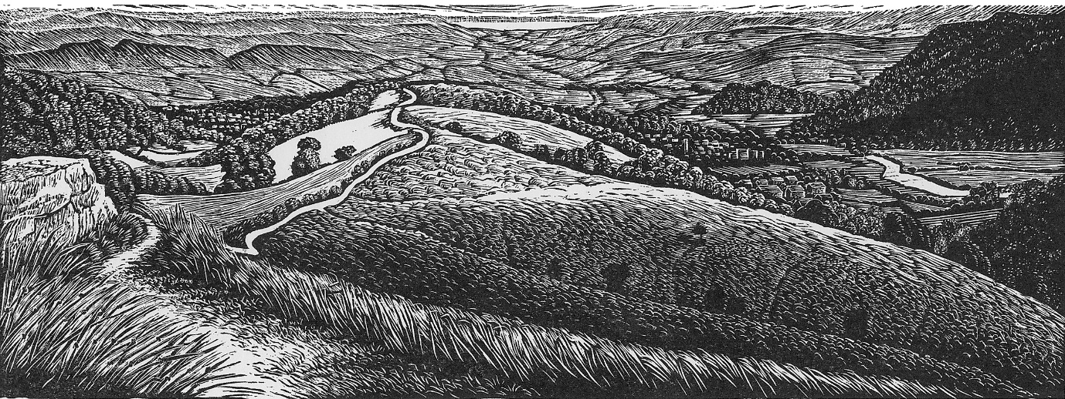
©Kathleen Littler Engraver, used by permission

Normally, I would place words from Scripture into their context, but these words from Romans chapter 1, jumped out at me:

Foolish, Faithless, Heartless and Ruthless 31.

A word of caution, if you do read the whole chapter of Romans, keep reading through into chapter 2 and beyond. Paul sets up a kind of theological trap here, encouraging us to feel good about just how bad the rest of the world is, but then he turns the spotlight around in chapter 2, so take care.

Paul warns us about foolishness. When it comes to climate change, we have all been foolish. Even in the 1970’s we were not sure what damage we might have been doing but acid rain was a bit of a clue! By the mid the 1980’s the evidence was clear. To keep burning fossil fuel and thinking nothing would happen was not wise. We have been foolish.

We have also been faithless. Jesus calls us onto the path that leads to life not death, to put the needs of others in front of our own. In 2017, Archbishop Fereimi Cama – Archbishop of Aotearoa, New Zealand and Polynesia called on the Anglican Communion to help them with the problems of global warming which was for them a daily struggle for survival. Our response has been slow we are not behaving as if there is a crisis.
Have we become heartless? No longer hearing the call of concern from across the world? Following the recent cyclones that hit Mozambique in 2019, I remember one of their government leaders saying how unfair this was, that his people, who had so little and contributed so little to global warming were the ones to face its consequences.
Above all I pray that we are not ruthless, profiting from the harm of others with no conscience or concern.

At the other end of Romans in Chapter 12, Paul describes the new Christian communities that he was founding.
He talked about being:

ardent in zeal, joyful in hope, patient in difficulty and constant in prayer.

Let us begin in Prayer, for a change of heart to walk the path that leads to life.

Following the reflection on Romans 1: 31

Father you have called me to walk the path that leads to life.

In my baptism, I am in Christ and He in me.

I turn away from ruthlessness, I will not profit from the harm of others.

I turn from heartlessness; I will not look away when others are suffering.

I am faithful because you are faithful.

I will walk wisely because all the treasures of wisdom and knowledge are hidden in you, and I have been baptised into you.

References: Matt 7:14, Gal 3:27, Col. 2: 3&10

“To live out my Christian faith is to follow Jesus. That must include standing alongside the most vulnerable and marginalised on the frontlines of the climate emergency. As faith communities, my prayer is that we might stand together, emissaries of hope and love, calling for God’s justice and peace upon this precious world. Now is the time for action.”
Archbishop Justin Welby

The Eco Eglwys Podcast by Diocese of Llandaff (soundcloud.com)

