Cadw Historic Buildings
Maintenance and Repair Capital Grant Programme 2022/23

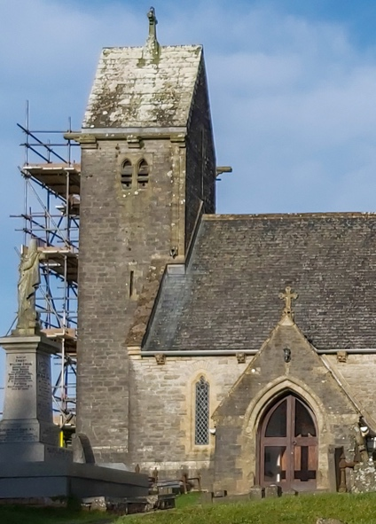

Cadw have opened their buildings grant application process for 2022/23 by which you can apply for 75% of grant eligible works up to a maximum of £25,000 per church/church hall. However, you’ll need to act quickly as the closing date for applications is 31st August 2022.

You will need a faculty or List B permission for the work, but Cadw will accept confirmation that an application has been made if you do not have the final permission in place. Contact martynjones@churchinwales.org.uk for help with the faculty process.

This link takes you to the Cadw website with full details of the criteria and application process.
Link to Cadw grant page

