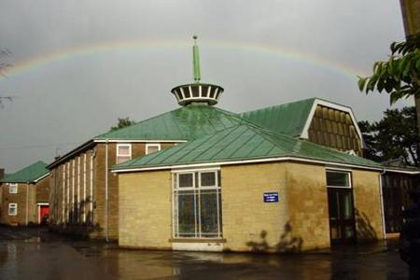
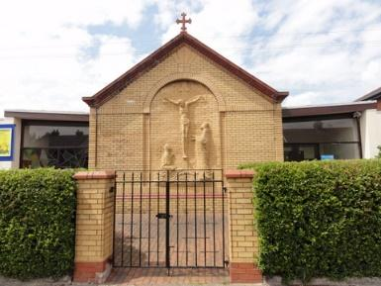
Application form:
Children and Family Pastor
Parish of St Mark’s Gabalfa and St Philip’s Tremorfa

Closing date: Oct 20th 2023

1. Personal details

Title and full name:
Address:
Mobile or Tel no.:
Email:

2. Education/qualifications – most recent first

Dates |  | Place of study | Qualifications attained
From | To

3. Present employment
Tell us about your current work, study and/or volunteering:

Name and address of  present employer: | Job/role title:
 | Date of appointment/commencement:
 | Notice required/finish date:

Please give details of duties and responsibilities:

4. Past employment (paid or unpaid) – most recent first
Please explain any gaps in employment

Dates |  | Name and address of employer | Job title and summary of duties | Reason for leaving
From | To

5. Relevant training courses – most recent first

Organising body | Course details | Dates

6. Tell us about yourself, your hobbies and interests outside of work

7. Describe the ongoing development of your own Christian faith and commitment

8. Give details of Christian ministry with children and families that you have been involved in

9. Describe your experience of leadership and working with teams

10. Give details of your experience of working with schools

11. Tell us about your involvement in mission & evangelism

12. Do you have any experience of working with children and young people with additional needs? Detail below:

13. Do you have any experience of working with multicultural communities? Detail below:

14. PERSONAL STATEMENT - Having read the Profile about the church, our job description and person specification, please give your reasons for applying for this post and explain what you would hope to bring to it.
15. References - Please provide two references one of whom should be able to comment on your current employment (an employment reference would only be requested with prior consent).

Name:  Job Title:  Address:  Post code:  Telephone number:  Email:  Relationship to you: | Name:  Job Title:  Address:  Post code:  Telephone number:  Email:  Relationship to you:

16. Driving

Do you have a full, clean driving licence and use of a car? Yes / No

17. DBS Check – The role requires working with children and vulnerable adults and so a DBS check will be carried out before appointment. Do you foresee any issues in obtaining this?

18. Declaration

I certify that to the best of my knowledge, the information given on this form is correct.

Signature: . . . . . . . . . . . . . . . . . . . . . . . . . . . . . . . . . . Date: . . . . . . . . . . . . . . . . . . . . .
Please return this form to:

Email: office@stmarks-cardiff.co.uk

or

Post to St Mark’s Church, 206 North Road, Cardiff, CF14 3BL
Tel 02920 619211

